
In this issue!
-Message from your National Youth Rep
-Spring inspired Tea Party
-Are you a shopaholic quiz
-Recipe
-Devotions

Message from your National Youth Rep!

Hey! Thanks for reading the September edition of Something Worth Reading!

It is September! It is the ninth month of 2014! This time last year I was freaking out about what I would be doing this year, frantically applying for jobs and trying to decide what I was going to do this year. It's so good that I have God to rely on, especially as only a couple of my plans have actually come to pass, but that's not a bad thing. Jeremiah 29:11 says "For I know the plans I have for you," says the LORD. "They are plans for good and not for disaster, to give you a future and a hope." I know some of you will be coming up to the end of your last year at high school and possibly you're feeling a bit over whelmed about what you might be going to do next year... It's okay even after being out of school for almost a year every now and again I still have a wee freak out about what I'm going to do. There is so many options to choose from these days and I don't see any as bad options as long as they are in line with what God wants you to do. I wish you all good luck with your end of year exams, applications, and all the other stuff that comes with finishing school.

In other news, Youth Forum planning is coming along nicely. Start encouraging your Pioneers to think about coming along. Remember it is open to girls and leaders between the ages of 15 and 25, you don't have to be a Youth Rep to come along, you can come as an observer!
Also I will be attending a Board meeting this weekend, and there is a combined Auckland Areas Pirate event happening on Saturday night! Busy weekend ahead!

We'll better go, remember to keep on praying for the release of the Nigerian girls!

Sarah xx

Girls’ Brigade New Zealand
September Issue 2014
Something Worth Reading

Me and one of my
Best Friends Ruby
Welcome to Spring!!



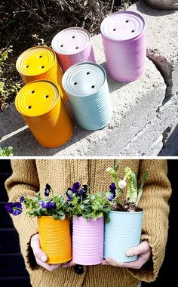
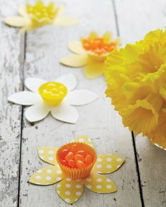
Celebrate the new season with a Spring inspired Tea Party that your Pioneers would love!
Here’s some ideas to inspire you!
Make these cute daffodils that could be used for table decorations or gifts. Make them with scrapbooking paper and cupcake liners. Fill them with orange and yellow jelly beans or M&M’s!

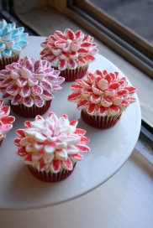
Upcycle tin cans into these gorgeous planters, by drilling holes in the bottom of the can, painting them with pastel colours, then filling them with potting mix. Plant some nice spring flowers like pansies and voila you have a really simple but beautiful table centre that can be used again and again.
Set up your tea party outside on a sunny afternoon under a beautiful blossom tree. Pick some bright spring flowers to add to the table.
Create some yummy and delicious looking spring flower cupcakes by using cut up marshmallows and coloured sugar. Ice the cupcakes as usual ans stick the marshmallows on top in the shape of a flower. You could make all sorts of flowers!

Are you a shopaholic? Try this quiz
Apart from home, where do you most often hang out? When you see the junk mail catalogues in the mailbox, do you:
a) friend’s house a) throw them all in the recycling
b) the park b) sift through them to get rid of the supermarket ones, and read the rest
c) the shopping centre c) attack them with a highlight and red vivid, and arm yourself for the best bargains
d) church d) what’s junk mail?
It’s a public holiday... The thought of not being able to get to the shops...
a) Excellent. Time for some chilling out with the family a) doesn’t bother you at all
b) Anything that involves less time at school is good b) Isn’t too big a problem. There’s always tomorrow
c) Reduced shopping hours??? Better get there quickly! c) What? What do you mean? There has to be shops. Always!!

Are you a shopaholic continued...
Now, if you answered (c) to most of those questions, chances are you’re a shopaholic. You don’t have to spend thousands to be addicted to shopping. You can just be addicted to the buzz of finding a great bargain. The cycle of shopping addiction starts with making you unhappy. That’s what advertising does. You see that ad, magazine photo shoot, whatever, and suddenly you know you’ll only be happy when you have that item. So you go to the shops, where everything is bright and shiny and new. Your brain gets a real buzz from buying the item, and it’s all fantastic until you return home, when you’ve only got a few little bags of stuff. Then you’re discontent again, and you need more stuff. So off to the shops you go. Again. The man who had everything... Jesus told a story about a man who was in a similar situation. You can read about him now in Luke 12:13-21. He wasn’t content with what he had either. He wanted to get more stuff so he’d be able to say “You have plenty of good things laid up for many years. Take life easy; eat drink and be merry.” (Luke 12:19) Did God ever enter into his thinking? Nope. God’s final statement is chilling: “You fool! This very night your life will be demanded from you. Then who will get what you have prepared for yourself?”
Advertising, fashion mags, shop displays all promise us an easy life. They say, “Buy us, and you’ll be gorgeous!” or “Buy this, and you’ll be the envy of all your friends!”But their promises are false. They trap us into living a life a little bit like a mouse on a wheel: always chasing after the illusion, and never getting there.
Jesus wants us to get off that wheel, and focus on him instead. His story should be a warning to us: “This is how it will be with anyone who stores up things for themselves but are not rich toward God.” (Luke 12:21) Don’t waste your energy on the mousewheel of shopping. Focus on what will last, no matter what: our relationship with Jesus. That’s forever.

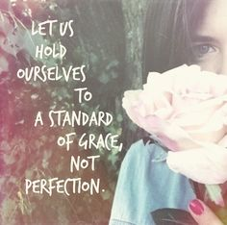
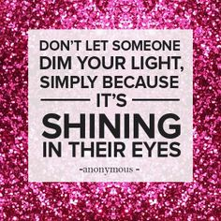
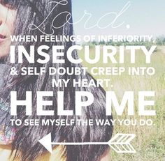
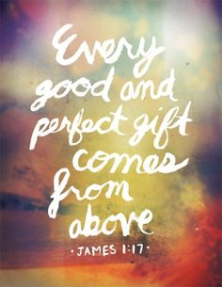
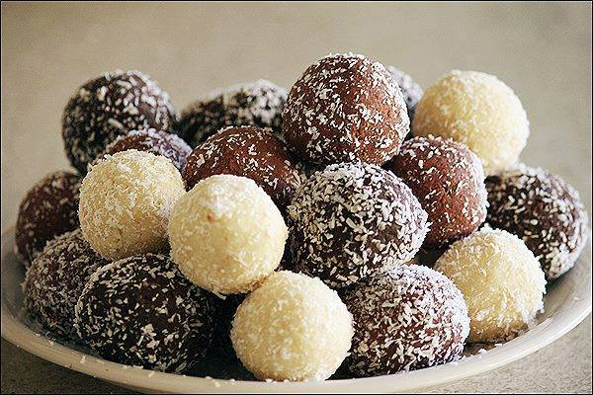
Tim Tam Truffles

One of the easiest and most delicious recipes ever. Good luck with just stopping at one!
Ingredients: Method:
2 packets of Tim Tam's 1. Crush Tim Tams in food processor
3/4 can of 395g condensed milk 2. Fold in Condensed Milk
Desiccated coconut or grated chocolate 3. Roll mixture into balls, then roll in coconut or grated chocolate
4. Refrigerate until firm
Variations: Use cream cheese instead of condensed milk and/or dip the balls in melted chocolate instead of coconut or grated chocolate. You can also use mint slice biscuits or Oreo cookies for another variation.
Struggling with self-image? You may be listening too much to the media, and not enough to your creator.
Today’s society views "beautiful" as ______________ (fill in the blank). I am sure every young woman reading this article right now can come up with a whole list of physical characteristics that are deemed as beautiful or desirable based on what society says is the "ideal image". One demonstration of this ideal image can be seen in childhood toys. Remember Barbie? She has it all. She has straight white teeth, unusually large breasts, an ultra thin waist, perfect hair, a hot boyfriend and a number of successful careers (depending on which one you buy)! Who wouldn’t want to be her, right?
However, did you know that research shows that if Barbie were a real life woman, she would have to walk on both her hands and feet because her proportions are so off?* Surprised? I wasn’t. From the time we are young and play with Barbie dolls up until now, our culture has been feeding us messages about how we should look and who we should be. It could even be said that the advertisements we see on a day-to-day basis try to assert that a certain physical appearance will result in a happier, more successful life.
How does the media do it? The purpose of advertisements is to promote and sell products and/or lifestyles. Because of these goals to promote and sell, advertisers create visual images that distort reality and create unobtainable standards for both men and women. A majority of what we see is airbrushed, cropped, re-touched, enhanced virtually, etc. In a matter of seconds, advertisers can transform one image into something completely different. What’s interesting is that, although these images and graphics are not real, they still have the power to shape our mind sets about who we are and who we expect ourselves, and even others, to be.
Everyone, at one time or another, has been or will be under the influence of these artificial images. Think about it for a moment. Look at the clothes you are wearing right now. Where did you get them from and what made you want to buy them? Most people, if they were being honest, would say the way they dress has been influenced by an outside source. This source could be either someone they have personally encountered (such as a peer or family member), or something they have visually taken in from the media. Now, is this necessarily wrong? Not exactly. The problem comes when we start viewing ourselves in light of the media’s standards, which are typically based upon false realities.
The reality: My story - How can I be so certain that media and outside influences affect the way in which women view themselves? It’s because I have personally experienced it. During my freshman year in college, I struggled tremendously with my self-image. I struggled with the desire to fit-in and became consumed with looking like the other female students on campus. I began wearing what I thought would make me more fashionable like the other girls. I can clearly remember times when I would spend money carelessly, every time I went to the mall, just so I could obtain the latest styles or some of the most popular name brands. Not only did I transform the way in which I dressed, but I also became obsessed with working out (losing a total of twenty pounds that year). To my surprise, although having a smaller body made me feel more confident in my physical appearance, I realized that I was never truly satisfied with who I was becoming. In all truth, I felt worse about myself because I was looking to clothes and a slimmer body to define me, instead of looking to God to give me an identity. It was not until I went home for Thanksgiving break, when one of my past sunday school teachers kindly reminded of my worth, that I realized my mindset was wrong.

Continued from previous page....

Designer made.
The truth is, it is easy to get caught up in trying to obtain a certain weight and/or size. It is difficult to not look at the models in the magazines and feel tempted to be like them or compare yourself to them. It is a challenge to accept yourself for who you are. However, there are some things you can do to lessen - or even completely eliminate - the media’s grip on your life. The following are just a few: Be more aware of the magazines you flip through. Trash the ones that tempt you to make comparisons or feel inadequate Monitor the types of movies and/or music you immerse yourself in, avoiding whatever fills your mind with harmful images
Change your internal voice from negative thoughts about yourself to only positive, based on what God says about you, not what the media says
The key is realizing you have been designer made by the Ultimate Designer. When you realize this, you are acknowledging that you have worth and value that goes beyond your physical appearance. You are a girl or woman, boy or man, who is precious and honored in God’s sight (Isaiah 43:4). Every part of you - from your hair color to your personality to that laugh you can’t stand - is all part of his plan.How do I know? Because God said it! He says you have been made fearfully and wonderfully (Psalm 139:14). The Designer has a plan that is so unique for your life (Psalm 138:8). Comparing yourself to other people and the images you see in magazines will only distract you from living the life that he designed for you even before you were born. Your job is to take hold of all he has to offer you. Enjoy every moment. Look to him, and him alone, to show you how you should live.
Devotion from fervr.net


Like us on
Facebook
Girls’ Brigade New Zealand

GB Support Centre
PO BOX 100 983
North Shore 0745

National Youth Rep
Sarah Millar – 0277586991
ibanez.girl@hotmail.com
National Youth Rep Elect
Jess Goodwin – 0211409374
jeggie1993@gmail.com

